The Annual Dinner

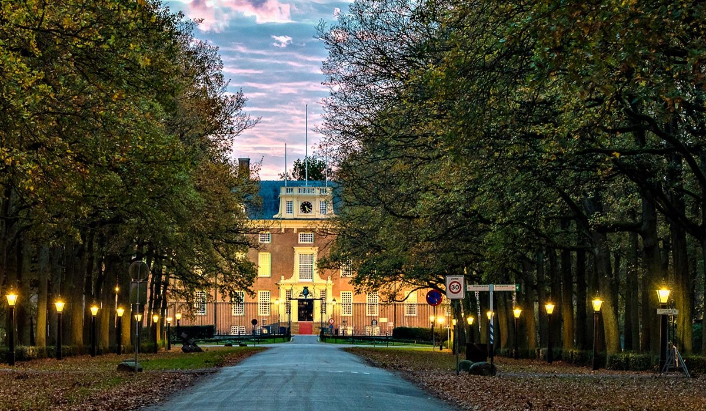

THE OXFORD AND CAMBRIDGE SOCIETY OF THE NETHERLANDS has great pleasure in inviting you to our Annual Dinner held in Slot Zeist.

Our speaker and guest of honour is the Honourable Peter Wilson CMG who was appointed Her Majesty’s Ambassador to the Kingdom of the Netherlands in August 2017. Prior to this, Ambassador Wilson was the Ambassador and Deputy Permanent Representative of the UK Mission to the UN, New York. His previous postings have included service at the Foreign and Commonwealth office and the British Embassy in Beijing. He has also ran the European Parliament Team at the UK Representation to the European Union in Brussels. Ambassador Wilson is also an Oxbridge alumnus having obtained a Bachelors in Modern History from Oxford University.

When? | Friday, October 12th, 2018
19.00 – 19.30 | Welcome reception
19.30 – 22.30 | Dinner. Three-course meal (Menu du Chef) including drinks.  Guest lecture by the honourable Peter Wilson CMG
Where? | Sot Zeist, Zinzendorflaan 1, 3703 CE Zeist (free parking available)
Dress code? | Black tie is preferred
Costs? | €70 for members and €80 for non-members and guests

Registration form Annual Dinner

Please complete and send via email to secretary.OCNL@gmail.com, to be received no later than Oct. 5th (early response and payment is greatly appreciated!)

Friday, October 12th
Doors open at 7:00 pm
at
Slot Zeist

I, [NAME], [COLLEGE, [UNIVERSITY],.……..……………
wish to attend the annual dinner.

Please indicate here – YES/NO – whether you are a member of the society for the year 2018. The lower ticket price below applies only to members and to their guest.

I hereby confirm that I have sent my payment to the ING bank account of The Oxford and Cambridge Society of the Netherlands, NL20INGB0002225907, covering:

[ ] | Member(s) at €70 each | €
[ ] | Guests/non-members at €80 each | €
 |  | TOTAL €

Name of my guest(s):

My party includes […] vegetarians.

Other dietary requirements:

