An afternoon at the auction house Van Zadelhoff

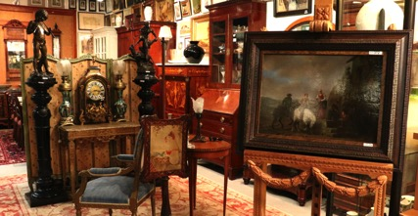

THE OXFORD AND CAMBRIDGE SOCIETY OF THE NETHERLANDS has great pleasure in inviting you to a fantastic afternoon at the auction house Van Zadelhoff (Hilversum, http://www.vanzadelhoff.nl). One of our members put together an exciting program covering a lecture, “behind the scenes”, High Tea and an appraisal of your possibly valuable possessions. So do not hesitate, and sign up on the following page.

Where? | Van Zadelhoff, Nieuwe Havenweg 53a, 1216 BL Hilversum
 | For directions use: https://goo.gl/maps/hnjqMuLUw3U2
When? | Sunday, October 16th, 2016
13.30 – 14.00 | Welcome reception with champagne and soft drinks
14.00 – 15.00 | A lecture about the history of auctions and auction types and a private tour through the premises. A few highlights of the current auction will be presented including the demonstration of a very rare Jugendstil barrel piano by Keith Prowse & Co Ltd., London (1880)
15.00 – 16.00 | High Tea – Traditional English Afternoon style
16.00 – 17.00 | “Between Art and Kitsch” with a certified appraiser, so bring your hidden treasures and get them valued! In the Netherlands “Tussen Kunst & Kitsch” is a famous Dutch television program where people can bring possessions, art, collectibles and heirlooms to museums during open days where specialist art and antique appraisers examine and value the goods. Sometimes visitors discover extraordinary treasures or they find out that the painting that has been in the family for years is merely a skilled forgery.

Registration form

Please complete and send via email to secretary.OCNL@gmail.com, to be received no later than Oct. 10th (early response and payment would be greatly appreciated!)

Sunday, Oct. 16th
Doors open at 1:30 pm
at
Van Zadelhoff
Nieuwe Havenweg 53a
1216 BL, Hilversum

I, [NAME], [COLLEGE, [UNIVERSITY] .……..……………
wish to attend the event.

I hereby confirm that I have sent my payment to the ING bank account of The Oxford and Cambridge Society of the Netherlands, NL20INGB0002225907, covering:

[ ] | member(s) at € 20 each | €
[ ] | guests(s) at € 20 each | €
 |  | TOTAL €

Names of my guest(s):

I am likely to [arrive by car] / [use public transport]

